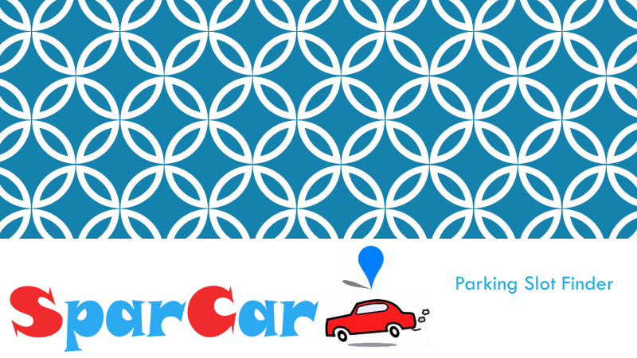

**What is your Idea?**

SparCar is the mobile application that provides an easy way of finding the parking slot in rushy areas so that anyone can find parking slot to his/her preference at any location at any time.

**Who has the Problem?**

The person who or whose car is need of Parking area is the Customer to SparCar.

**Why is it a pain?**

Vehicle owner who has a requirement of parking are difficult to find the nearest available parking slots. Thence they park beside roads and unofficial or No Parking zones which leads to traffic congestion.

**What is the problem?**

* India is the world’s fourth largest automobile market with limited parking spots. Ever-growing number of vehicles causes traffic congestion on most streets and roads.
* Availability of a low cost connected ecosystem will help identify the nearest parking spot when sought

**How are we solving?**

SparCar approaches you with complete new idea to make use of domestic parking places of houses, apartments and renting them to customers for parking place by making use of mobile application.

The novelty can be viewed as the usage of existing parking places which are semi-utilized or under-utilized into a proper purposeful usage by maintaining environmental sustainability and adaptability without creating and constructing a new parking place.

**What is the way?**

SparCar is the mobile application that provides an easy way of finding the parking slot in rush areas so that anyone can find parking slot to his/her preference at any location at any time.

SparCar can be subdivided into two main modules and one interface. Modules are Customer and Slot Owner where as interface is the application itself.

**Competitors to SparCar**

|  |  |  |  |
| --- | --- | --- | --- |
| S.No | Solution name/competition | Features | Remarks |
| 01 | Parking in Bus/railway Stations | Pay and use basis | No Prior detection of vacancy |
| 02 | Parking in private parking zones | Pay and use basis | No Prior detection of vacancy |
| 03 | Parking in Shopping Malls | Pay and use basis | No Prior detection of vacancy |

**Specific Customers to SparCar:**

The person who or whose car is need of Parking area is the Customer to SparCar.

The Person who provides parking space is also the Customer to SparCar.

**How to get initial Customers:**

**Viable:**

The Scaling factor of the SparCar ranges very high because it covers almost all levels of middile class people who possess a car.

SparCar’s scalability can be divided on the basis of types of users mainly Customer and Slot Owner.

The scalability can also classified based on the features on application like based on car model i.e the customers can be a rich man with costly car, or a common man with budget friendly car.

The user can be a daily commuter or can be occassional one, a tourist to that area and want to park car somewhere in safe place or may be a family man who came to shopping.

Similarly the Slot owner can also of any kind as above mentioned .

Thus, the scope of utility of SparCar is very high because the scalability is extremely large and flexible.